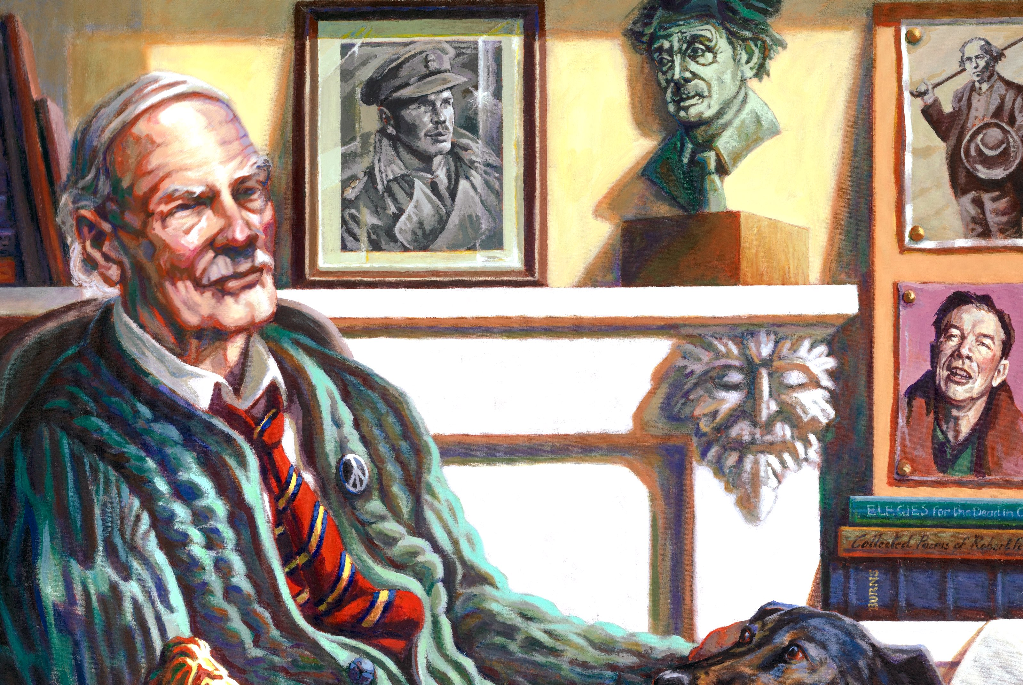

Hamish HENDERSON

An Artist's inspiration
11 February 2026
6-9.30 pm

Royal Conservatoire
of Scotland
100 Renfrew St,
Glasgow G2 3DB

Presented by: Charles Nasmyth
Produced and Directed by:
Michael Lloyd

Tickets £12.50
available from venue
...a new film
'Inspiration'

Presented by:
Charles Nasmyth
Produced and Directed by:
Michael Lloyd

Tickets - Free
available from venue
Somerset Maugham award-winning poems,' Elegies for the Dead in Cyrenaica.'
Growing up under influences from all shades of society left Hamish free to navigate Britain’s class-based culture, without feeling out of place in any company.
Paradoxically, he didn't let his socialist internationalism stand in the way of a passionate belief in self-determination for Scotland. He didn't raise Scotland above its merits - but valued the country for what it really is.
Charles admires Hamish's integrity. Henderson never sold out or compromised his beliefs, even when they caused personal conflict.
How iconic folklorist and poet, Hamish Henderson, inspired artist,
Charles Nasmyth ...
In this new film, Nasmyth looks at the man behind the legend and asks who he really was? Why was he inspired by Hamish's personality, to paint his portrait?
Hamish is sometimes seen as a mildly eccentric figure, hefted to the convivial atmosphere of Sandy Bells bar in Edinburgh, holding court amongst musicians and scholars.
But a key element in Hamish's development, was his war-time experience in the Libyan desert. He expressed this movingly in his

